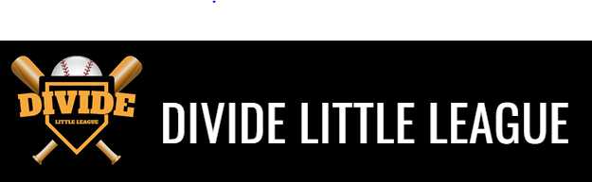
Parent / Guardian Code of Conduct
The essential elements of character building and ethics in sports are embodied in the concept of sportsmanship and six core principles: trustworthiness, respect, responsibility, fairness, caring and good citizenship. The highest potential of sports is achieved when competition reflects these “six pillars of character.”
I (We) …
- will not force my child to participate in sports.
- will remember that children participate to have fun and that the game is for youth, not adults.
- inform the coach of any physical disability or ailment that may affect the safety of my child or the safety of others.
- notify the coach if my child will not be at practices or games.
- learn the rules of the game and the policies of the league.
- and my guests will be a positive role model for my child and encourage sportsmanship by showing respect and courtesy, and by demonstrating positive support for all players, coaches, officials and spectators at every game, practice or sporting event.
- and my guests will not engage in any kind of unsportsmanlike conduct with any official coach, player or parent, such as booing and taunting, refusing to shake hands or using profane language or gestures.
- will not encourage any behaviors or practices that would endanger the health and well-being of the athletes.
- will teach my child to play by the rules and to resolve conflicts without resorting to hostility or violence.
- will demand that my child treat other players, coaches, officials and spectators with respect regardless of race, creed, color, sex or ability.
- will teach my child that doing one’s best and competing fairly is important.
- will never ridicule or yell at my child or other participants for making a mistake or losing a competition.
- will emphasize skill development and practices and how they will benefit my child.
- will promote the emotional and physical well-being of the athletes ahead of any personal desire I (we) may have for my child to win.
- respect the officials and their authority during games and will never question, discuss, or confront coaches at the game field, and will take time to speak with coaches at an agreed-upon time and place.
- will demand a sports environment for my child that is free from drugs, tobacco and alcohol and will refrain from their use at all sports events.
- will refrain from coaching my child or other players during games and practices, unless I am one of the official coaches of the team.

Child’s name: _______________________________________________________

Parent / Guardian Signature: ________________________________________________ Date:_____________________________

